Lab-Project 9: Capturing Passwords from RAM on a Mac
What You Need for This Project
- A Mac OS X computer
- A second computer of any type, even a cell phone
Downloading Mac Memory Reader
Download "Mac Memory Reader 3.0.2' from
http://cybermarshal.com/index.php/cyber-marshal-utilities/mac-memory-reader
In a Terminal window, execute these commands:
cd Downloads
tar xzf MacMemoryReader_3.0.2.tar.gz
cd MacMemoryReader
Now Mac Memory Reader is ready to use.
Capturing RAM
In a Terminal window, execute these commands, as shown below:
cd ~/Downloads/MacMemoryReader
sudo ./MacMemoryReader ram
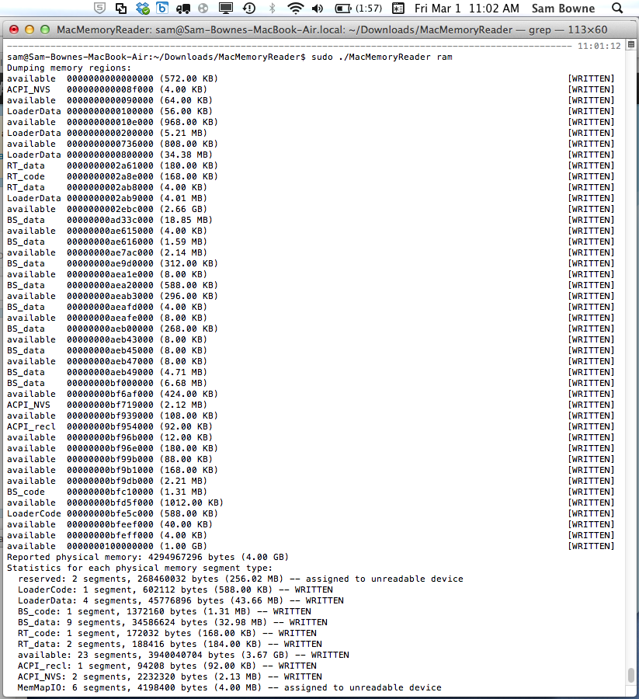
When the process finishes, you have a file named "ram" that has the entire contents of your current ram.
In a Terminal window, execute these commands, as shown below:
ls -l
cat ram | strings - - > ramstr
The second command will take a few minutes to complete. It harvests all the readable strings from ram and puts them into a file named "ramstr".
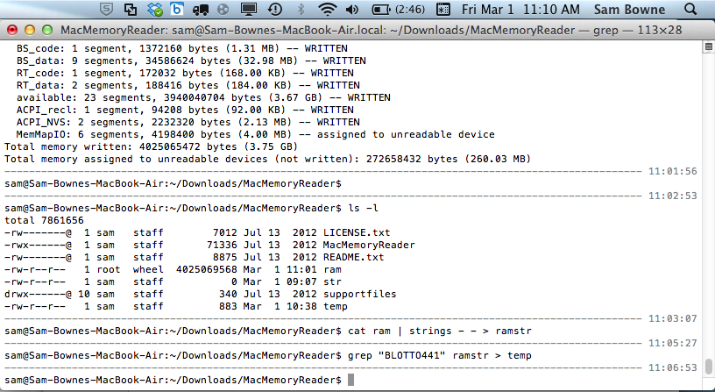
Searching for BLOTTO441
In a Terminal window, execute these commands:
grep "BLOTTO441" ramstr > temp
nano temp
This searches for the string "BLOTTO441" in the captured RAM. It should not be there, so nano should show an empty file.
If you repeat this project, the string may actually be there. In that case, add another digit to the end of the string to find a string you haven't used yet.
Creating a Twitter Account
USE YOUR OTHER COMPUTER!
Don't use your Mac to create the account.
On your other computer, go to http://twitter.com
Create a new account with any name you like and this password:
BLOTTO411YOURNAME
Replace YOURNAME with your own name.
Logging in on the Mac
On the Mac, in a Web browser, go to http://twitter.com
Log in to the account you just created.
Capturing RAM Again
In a Terminal window, execute these commands:
cd ~/Downloads/MacMemoryReader
rm ram
Enter "y" to confirm the deletion.
In the Terminal window, execute these commands:
sudo ./MacMemoryReader ram
cat ram | strings - - > ramstr
grep "BLOTTO441" ramstr > temp
nano temp
You should see several lines, containing the string BLOTTO441YOURNAME, as shown, e.g. below:
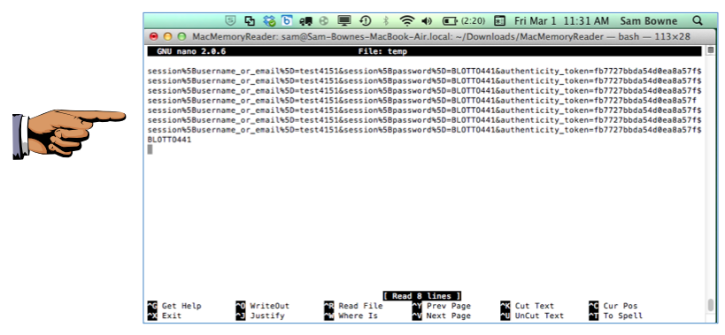
Reflection
Notice that a single login causes many copies of your password to be stored in RAM. And even though the password is encrypted when sent to Twitter via HTTPS, the RAM data is not encrypted. This is one reason RAM analysis is so important.
Saving a Screen Image
Make sure your screen shows BLOTTO411 and YOUR NAME.
Press Shoft+Command+3 to capture an image of the entire desktop. It appears on the desktop as a "Screen Shot" file.
Rename the image to the filename "Your Name Lab-Proj 9". Use your real name.
Turning in your Project
Email the image to the instructor as an email attachment. Send it to: xxx@fe.edu.vn with a subject line of "Lab-Proj 9 From Your Name", replacing Your Name with your own first and last name. Send a Cc to yourself.

